NATIONAL UNIVERSITY OF SCIENCES AND TECHNLOGY

(DEPARTMENT OF MECHANICAL AND MANUFACTURING ENGINEERING)

FOP HOME TASK 5

NAME: MANAHIL SHAHZAD

SUBMITTED ON: 28-10-2023

CMS ID: 466695

**TASK 1:**

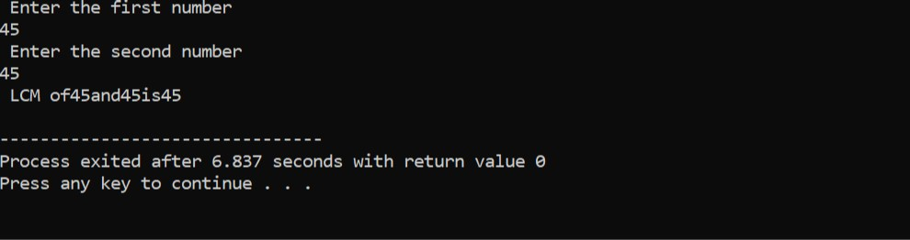

#include<iostream>

using namespace std;

int findHCF( int a, int b){

if( b==0){

return a;

}

return findHCF( b,a %b);

}

int findLCM( int a,int b){

int hcf = findHCF(a,b);

int lcm =(a*b)/ hcf;

return lcm;

}

int main() {

int num1 ,num2;

cout<<" Enter the first number"<<endl;

cin>> num1;

cout<<" Enter the second number"<<endl;

cin>> num2;

int lcm= findLCM( num1 ,num2);

cout<<" LCM of" <<num1<< "and"<<num2<<"is"<<lcm<<endl;

return 0;

}

**TASK 2:**

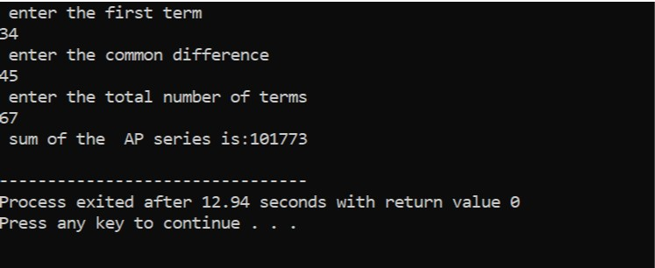

#include <iostream>

using namespace std;

int main(){

double firstTERM, commonDIFFERENCE;

int numberOFterms;

cout<<" enter the first term"<<endl;

cin>> firstTERM;

cout<<" enter the common difference"<<endl;

cin>>commonDIFFERENCE;

cout<<" enter the total number of terms"<<endl;

cin>> numberOFterms;

double sum = (numberOFterms *( 2* firstTERM +( numberOFterms-1)* commonDIFFERENCE)) /2;

cout<<" sum of the AP series is:"<<sum<<endl;

return 0;

}

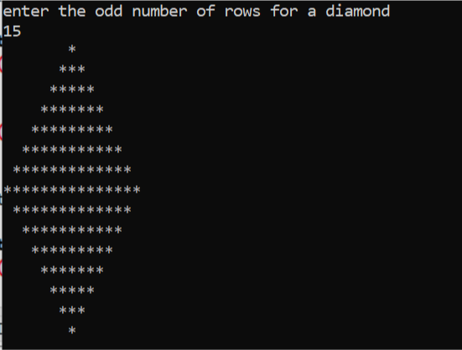**TASK 3:**

#include <iostream>

using namespace std ;

int main() {

int m;

cout<<"enter the odd number of rows for a diamond"<<endl;

cin>>m;

if ( m %2==0){

cout<<" enter an odd number for a proper diamond pattern"<<endl;

return 1;

}

for( int i=1; i<=m; i+=2){

for( int j=0; j<(m-i)/2; j++){

cout<<" ";

}

for( int j=0;j<i;j++){

cout<<"*";

}

cout<<endl;

}

for( int i=m-2;i>=1;i-=2){

for( int j=0;j<(m-i)/2;j++){

cout<<" ";

}

for( int j=0;j<i;j++){

cout<<"*";

}

cout<<endl;

}

return 0;

}

**TASK 4:**

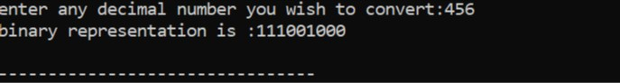

#include <iostream>

#include <stack>

using namespace std ;

int main() {

int DECIMALnumber;

cout<<"enter any decimal number you wish to convert:";

cin>>DECIMALnumber;

if(DECIMALnumber<0){

cout<<"enter non-negative decimal number:";

return 1;

}

stack<int>binaryDIGITS;

if(DECIMALnumber==0){

binaryDIGITS.push(0);

}else{

while(DECIMALnumber>0){

binaryDIGITS.push(DECIMALnumber%2);

DECIMALnumber/=2;

}

}

cout<<"binary representation is :";

while(!binaryDIGITS.empty()){

cout<<binaryDIGITS.top();

binaryDIGITS.pop();

}

cout<<endl;

return 0;

}